Git Workflow Assignment
1. Repository Creation and SSH Configuration
A new GitHub repository was created for performing all Git workflow tasks. The repository was cloned to the local machine using SSH authentication. SSH keys were generated and added to the GitHub account to establish secure communication between the local system and the remote repository.
This task demonstrated:
- GitHub repository management
- SSH authentication setup
- Secure repository cloning
- Local and remote repository synchronization
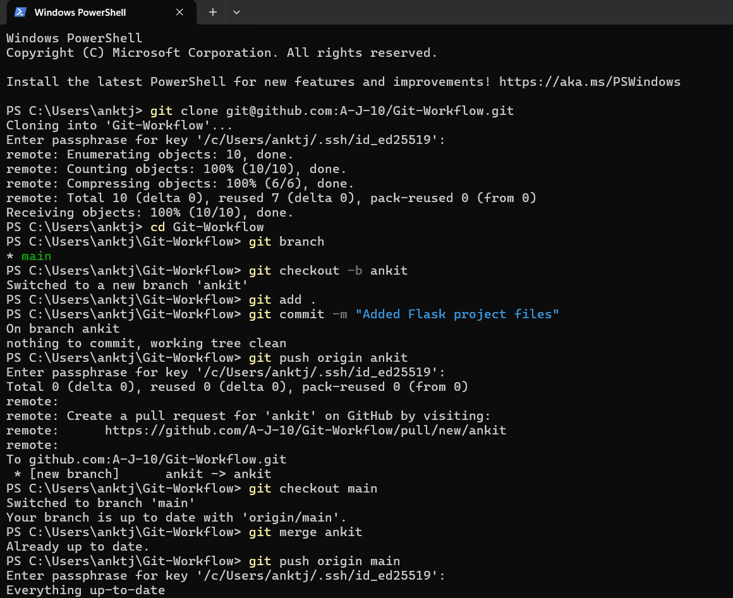

2. Branch Creation and Initial Project Merge
A new branch named after the username was created from the main branch. The Flask project files were added to this branch, committed, and pushed to the remote repository. After verifying the changes, the branch was merged into the main branch.
This task demonstrated:
- Branch creation
- Staging and committing changes
- Pushing branches to GitHub
- Merging branches into main
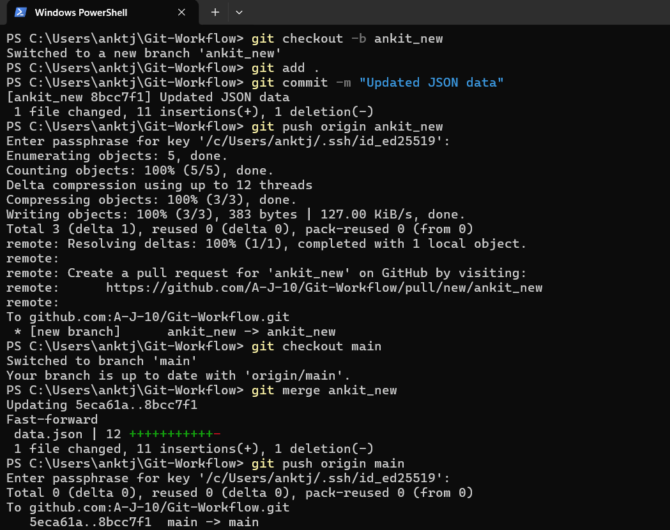

3. Updating JSON Data in a Separate Branch
Another branch named <username>_new was created to modify the JSON data used in the Flask /api route. The contents of the JSON file were updated, committed, and merged into the main branch. During merging, conflicts were handled by accepting the updated changes from the new branch and completing the merge process successfully.
This task demonstrated:
- Working with multiple branches
- Updating backend API data
- Merge conflict handling
- Conflict resolution and commit management
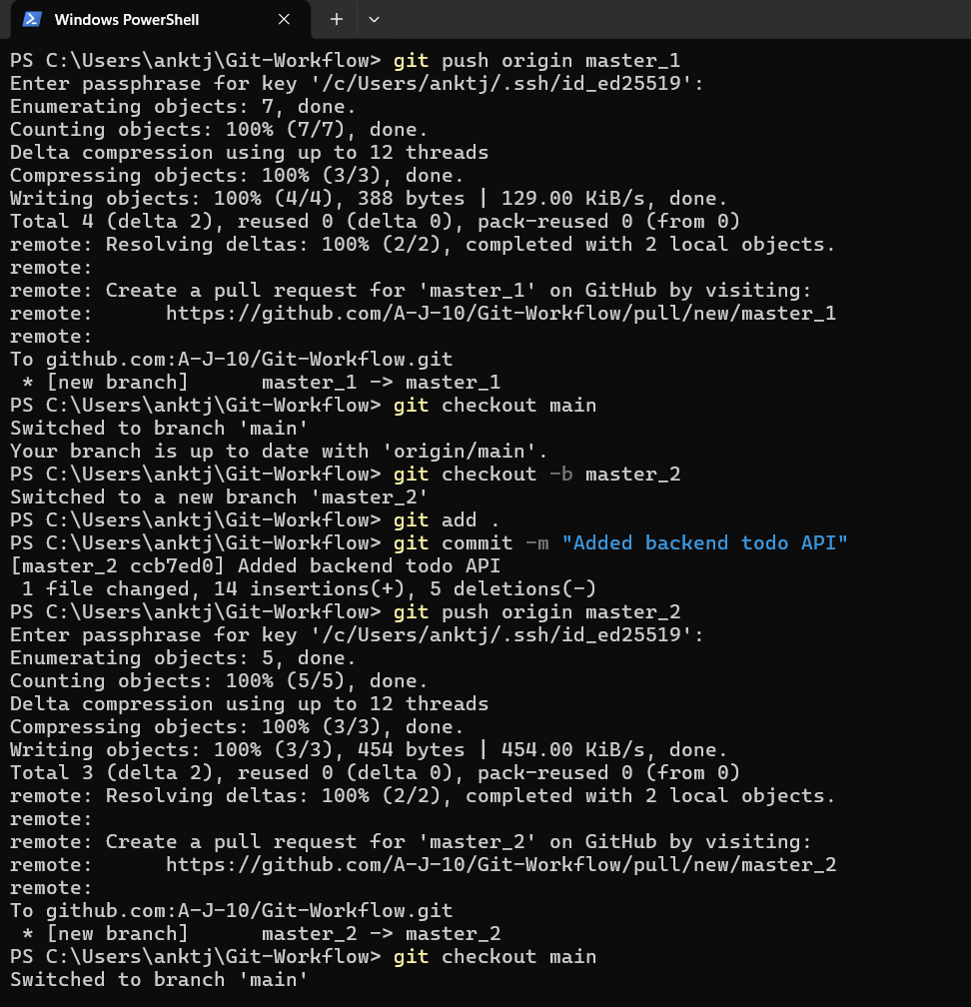

4. Frontend and Backend Development in Separate Branches
Two separate branches named master_1 and master_2 were created from the main branch to simulate parallel development workflows.
Frontend Development in master_1
A To-Do page was created in the frontend containing:
- Item Name field
- Item Description field
This task demonstrated:
- Frontend form creation
- HTML form handling
- Independent feature development using branches
Backend Development in master_2
A backend API route named /submittodoitem was created. The route accepted itemName and itemDescription through a POST request and processed the submitted data.
This task demonstrated:
- Flask route creation
- POST request handling
- Backend API development
After completing both features, the changes from master_1 and master_2 were merged into the main branch.
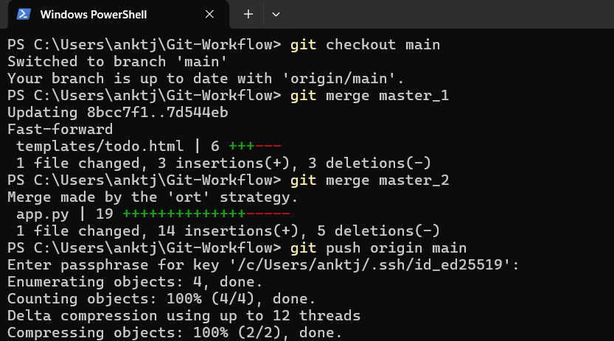

5. Sequential Commits and Form Enhancement
In the master_1 branch, the To-Do form was enhanced by adding the following fields one by one:
- Item ID
- Item UUID
- Item Hash
Each field addition was committed separately to maintain proper commit history.
This task demonstrated:
- Incremental development
- Maintaining detailed commit history
- Feature-based commit practices
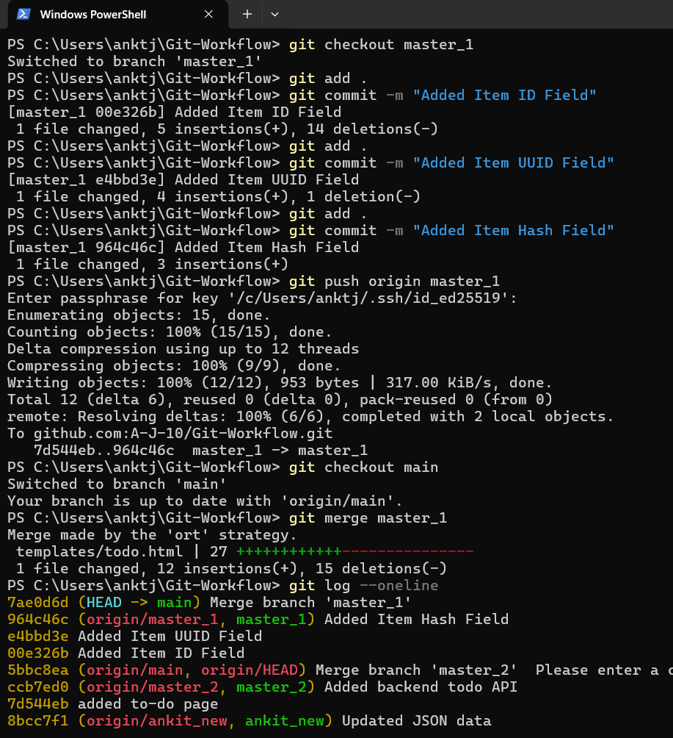

6. Git Reset and Commit Recovery
The main branch was reset back to the commit where only the Item ID field was present using:
git reset --soft
The reset preserved the changes in the staging area, allowing the state to be recommitted without losing work.
This task demonstrated:
- Git reset operations
- Soft reset usage
- Commit recovery and history modification
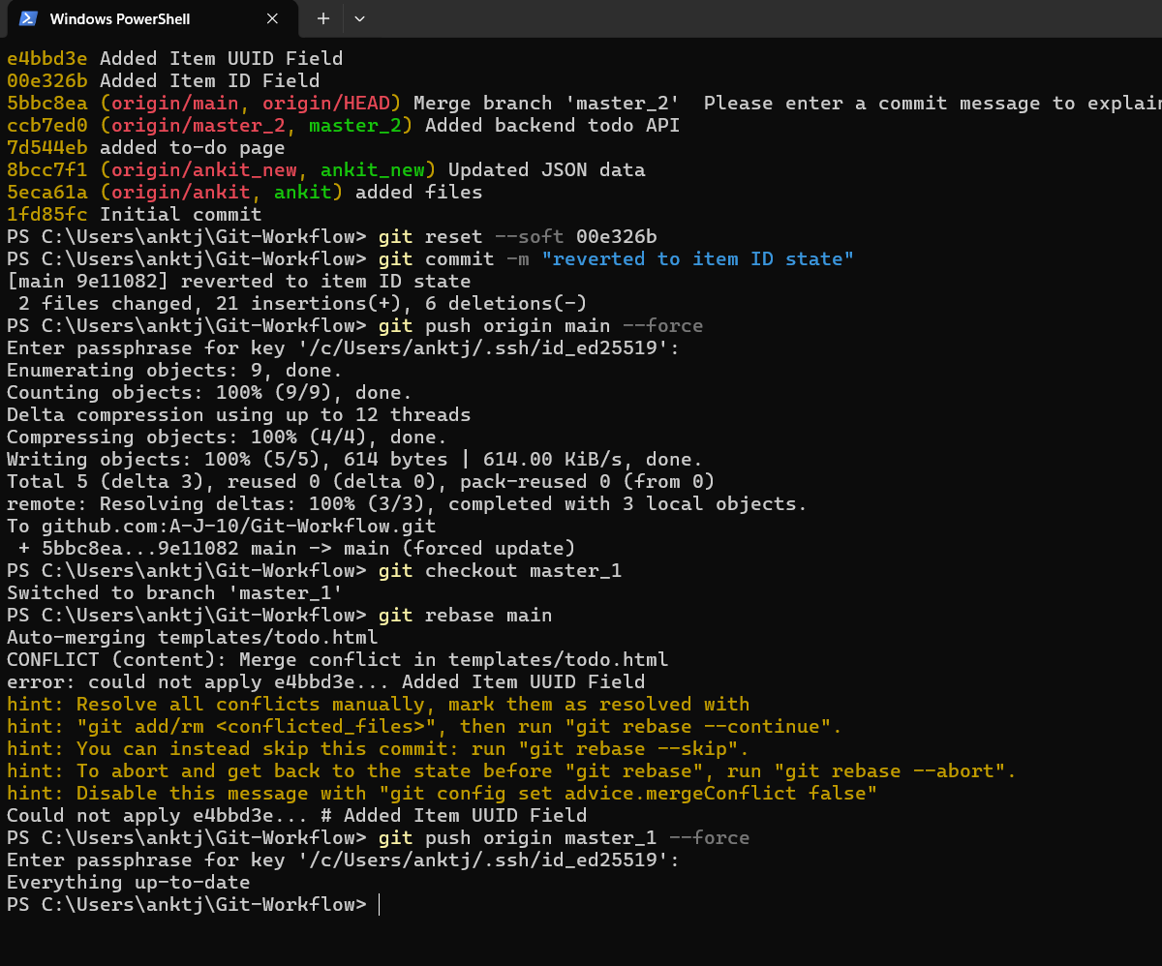

7. Rebasing Branches
The updated changes from the main branch were rebased into the master_1 branch while preserving individual commits. Rebasing was performed without squashing commits to maintain the complete development history.
This task demonstrated:
- Git rebase operations
- Commit history preservation
- Integrating updated branch changes cleanly

